**Blue Book on**

**FPGA based Blind Assistance System**

*Of*

**BACHELOR OF ENGINEERING**

*In*

ELECTRONICS ENGINEERING

*By*

Group No.01

Omkar Nandan Choudhary (06)

Ishaan Shinde (38)

Arun Kumar Singh (40)

Under the Guidance of

**Dr. Sandhya Save**

Department of Electronics

Thakur College of Engineering and Technology

Thakur Shyam Narayan Marg, Thakur Village, Kandivali (E), Mumbai-101

**Year 2020-2021**



## CERTIFICATE

This is to certify that **Choudhary Omkar Nandan, Ishaan Anand Shinde, Arun Kumar Singh** are bonafide students of Thakur College of Engineering and Technology, Mumbai. They have satisfactorily completed the requirements of the PROJECT-I as prescribed by University of Mumbai while working on **“FPGA based blind assistance system”**

|  |  |  |
| --- | --- | --- |
| **Dr. Sandhya Save**  **(INTERNAL GUIDE)** |  | **Dr. S.C. Patil**  **(HOD ELEX)** |
| **Internal Examiner**  **(Name & Signature with Date)** | **Dr. Kamal Shah**  **(Dean R&D)** | **External Examiner**  **(Name & Signature with Date)** |
|  | **Dr. B.K. Mishra**  **(Principal)** |  |

Thakur College of Engineering and Technology

Kandivali (E), Mumbai-400101.

PLACE: MUMBAI

DATE:

**ACKNOWLEDGEMENT**

Our project, ‘**FPGA based blind assistance system**’ has not been doneby individual students alone, but along with the guidance and assistance of our teacher and project guide Dr. Sandhya Save who has been a key factor in the motivation and completion of the project. We are grateful to him for giving us the opportunity to create this project and guiding and supporting us in each and every way possible.

We are also thankful to our parents for providing all possible resources to gain the best possible knowledge.

Finally, we would thank our college ‘Thakur College of Engineering and Technology’ for providing us with a platform and the necessary facilities to make this project.

Omkar Nandan Choudhary (BE-ELEX 06)

Ishaan Shinde (BE-ELEX 38)

Arun Kumar Singh (BE-ELEX 40)

**ABSTRACT**

Sighted guidance is arguably the most efficient way of guiding the visually impaired. Sighted guidance system will provide haptic feedback to the user about the obstacles in the user's path. To detect these obstacles, different options are available for sensors. Among these we are using RGB-D camera to take advantage of its ability to provide both visual and depth data of the surrounding. This data is run through a YOLO based algorithm which will be trained to detect obstacles in the user's path and this will be relayed back to the user using Haptic feedback. The processing of the image and the algorithm will be running on a SOC board running Artix-7 FPGA. The FPGA can provide true parallel processing while maintaining reconfigurability and programmability. This system will be mounted on a standard white cane, reason being this piece of equipment is already familiar and a part of the daily life for the visually impaired. The sensor and a Zigbee transmitter is mounted on the cane while the FPGA board along with the receiver and a power source is on person with the user. This system will inform the user about obstacles in 5-8 meters range and will allow them to navigate around these obstacles easily and safely.

**CONTENTS**

|  |  |  |  |  |
| --- | --- | --- | --- | --- |
| **CHAPTER** |  | **TOPIC** | **PAGE NO.** | |
| **NO.** |  |  |  |  |
|  | • | Certificate |  | A |
|  | • | Acknowledgement |  | B |
|  | • | Abstract |  | C |
|  | • | List of figures |  | 1 |
|  | • | List of tables |  | 1 |
| **Chapter 1** | **Introduction** | | **1** | **– 4** |
|  | 1.1 | Importance of Project |  | 2 |
|  | 1.2 | Motivation |  | 3 |
|  | 1.3 | Scope of the Project |  | 4 |
| **Chapter 2** | **Proposed Solution** | | **5** | **– 7** |
|  | 2.1 | Current Scenario |  | 6 |
|  | 2.2 | Proposed Technology Solution |  | 7 |
| **Chapter 3 Analysis, Planning & Requirement** | | | **8–17** | |
|  | 3.1 | Software and Hardware Requirements |  | 9 |
|  | 3.2 | Project Planning |  | 16 |
| **Chapter 4** | **Design Phase** | | **18** | **– 22** |
|  | 4.1 | Designing of the block diagram |  | 19 |
|  | 4.2 | Designing of model |  | 21 |
| **Chapter 5** | **Applications** | | **23** | **– 24** |
|  | 5.1 | Possible Application of the project |  | 24 |
| **Chapter 6** | **References** | | **25** | **– 27** |
|  | 6.1 | References |  | 26 |

**LIST OF FIGURES**

|  |  |  |  |
| --- | --- | --- | --- |
| **Figure** | **Caption** | **Page** |  |
| **No.** | **No.** |  |
|  |  |
| **3.1.1** | Artix-7 FPGA Board | 8 |  |
| **3.1.2** | Kinect RGB-D | 9 |  |
| **3.1.3** | Mini Vibration Motor | 9 |  |
| **3.1.4** | Cane for Patients with Visual Impairment | 10 |  |
| **3.1.5** | Zigbee Wireless Module | 10 |  |
| **3.1.6** | X-CTU Dashboard | 11 |  |
| **3.1.7** | Xilinx Software Development Kit | 12 |  |
| **3.2** | Gantt Chart | 17 |  |
| **4.1** | Block Diagram | 19 |  |
| **4.2** | Block Diagram of Image Processing | 21 |  |

**LIST OF TABLES**

|  |  |  |  |
| --- | --- | --- | --- |
| **Table** | **Caption** | **Page No.** |  |
| **No.** |  |
|  |  |  |
| **3.1** | (a)- Hardware Component List | 13 |  |
| **3.1** | (b)- Software List | 14 |  |
| **3.2** | Planning of Project | 15 |  |

**Chapter 1**

**Introduction**

**1.1** **Importance of The Project**

Travelling is a part of our daily life; this can be between our home to the workplace or for some other purpose. Walking in an urban environment means there are several obstacles in the path, these may be fellow travellers, stray animals or some other obstacles. Navigating around these obstacles can be a problem for the visually impaired. Such inconvenience in travelling disrupts their daily life. This project aims to provide a solution for these issues faced by them. We focus our project on helping them navigate while walking. To do this, we are reinforcing the already in use walking stick used by them. We are planning to design a system which will be mounted on this stick and will enable them to micro-navigate in situations where relying only on the walking stick is not feasible. This system will see the path in front and will try to identify potential obstacles in the path and inform the user using haptic feedback. This will help them pre-emptively judge the surrounding layout and the approximate location of obstacles. Doing this will make it easier for them to travel and will save effort and time.

**1.2** **Motivation**

Around 62 million people in India are visually impaired, for them performing even basic daily tasks is a challenge. The aim of this project is to design a system that provides them with a means of navigation and assistance.

Developing a means of micro-navigation which can provide haptic feedback to the user. It needs to have low latency; this ensures safety of the user and it provides ample time to react to incoming obstacles. It should have a mechanism for tactile feedback showing the user location of the obstacles.

Visually impaired face many hindrances in performing daily tasks, this project aims to help them navigate unknown environment with ease. We focus this project on detecting obstacles within a radius of 5-7 meters. To implement this, sensors will be integrated with a FPGA board to detect any obstacles in the surrounding and these details will be relayed back to the user using tactile feedback.

**1.3** **Scope of the Project**

This project is focused on providing data on providing feedback about potential obstacles in a range of 5-7 meters. This range was decided as the average walking speed of a visually impaired person is 0.85 m/s [3]. This allows ample time for reaction to the user, as the average reaction speed of humans is 0.15 seconds for haptic feedback. Considering the average of 50ms [4] response time of a vibration motor, the user will be ready for action before reaching the obstacle. In this project, we will train the stick to identify potential obstacles in the path. This will be done using You Look Only Once (YOLO) algorithm. Here we are only focused on detecting an obstacle and we are not concerned with what the nature of the obstacle in our path is. This allows the algorithm to run faster, compared to an object recognition algorithm. Combined with the parallel processing power of an FPGA board, the latency between capturing the image and recognising an obstacle is low compared to processor-based systems and is more power efficient.

**Chapter 2**

**Proposed Solution**

**2.1** **Current Scenario**

A team from Brunel University has proposed the use of stereo vision as a visual odometry [1]. Another proposed solution to this problem is to build a virtual eye. This eye will observe the object in front of the user and relay back the information of the object to the user via sound [2]. The proposed work includes the design of a smart cane with multiple sensors connected to an Arduino board. They mounted ultrasonic and infrared sensors to detect obstacles. A buzzer, vibrator, and some recorded audio clips to navigate the blind people safely [5]. Draws attention to the shortcomings of existing solutions. The proposed solution is a jacket which has to be worn by the visually impaired. They mounted the Jacket with a collection of ultrasonic sensors to help the user [6]. The proposed system operates in two modes, namely hurdle detection mode and fixed mode. In this mode, the system detects solid and liquid obstacle sending respective instruction to the blind person through voice message via Bluetooth. The fixed mode provides the information and guidance to move from one place to another safely by setting a fixed route in a blind stick from source to destination location. The system uses GPS data, Bluetooth to assist the visually impaired [9].

**2.2** **Proposed Technology Solution**

In this project, the combination of a Field Programmable Gate Array (or FPGA) and an RGBD camera will be explored to get effective data about the surroundings of the user. The medium of haptic feedback will be used to alert the user. A 2V - 5V dc mini vibration motor will b e used. Haptic alerts are considered being one of the most preferred choices in types of feedbacks, as it eliminates the need for the user to wear any extra feedback equipment (like earphones, etc.) which might block or hamper the user’s natural ability of hearing. The Zigbee RF modules will be helpful in establishing communication between the main FPGA processing unit and the RGBD camera. Features of FPGAs like concurrent processing of data provide faster and reliable data at the outputs as compared to that of an Arduino or similar microcontroller boards. The RGB-D camera will be mounted on a general walking cane (for visually impaired), so the user doesn’t need to depend on or learn handling of any new equipment and can perform his or her task of daily commute with ease and assurance.

**Chapter 3**

**Analysis, Planning & Requirement**

**3.1** **Software & Hardware Requirement**

The hardware of the project comprises of the following:

1. FPGA: Artix®-7 Family

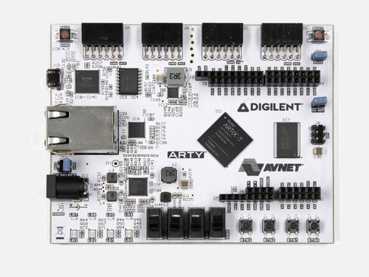Artix®-7 devices provide the highest performance-per-watt fabric, transceiver line rates, DSP processing, and AMS integration in a cost-optimized FPGA. Features 1,066Mb/s DDR3 support, the family is the best value for a variety of cost and power-sensitive applications including software-defined radio, machine vision cameras, and low-end wireless backhaul.

Figure 3.1.1 Artix - 7 FPGA Board

1. RGB-D-Sensor – Microsoft Kinect

Kinect is a device introduced in 2010 as an accessory to XBOX 360. The acquired data has different and complementary natures, combining geometry with visual attributes. For this reason, Kinect is a flexible tool that can be used in applications from several areas such as: Computer Graphics, Image processing, etc.

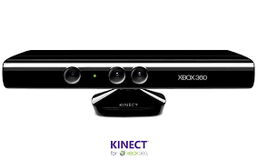

Figure 3.1.2 Kinect (RGB-D)

1. Vibration Motor

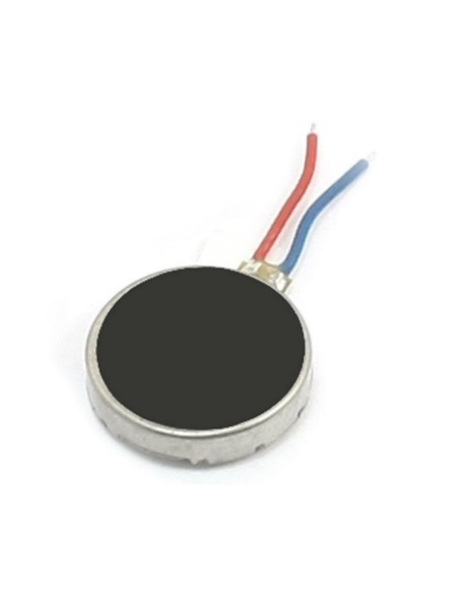This is a tiny round coin size vibration motor. Can be used to provide vibrational alerts. When powered, the vibration motor causes the attached surface to vibrate. This motor works with an input voltage as low as 2.5V. It has wire leads coming out from its body which can be used to solder the motor to a PCB.

Figure 3.1.3 Mini Vibration Motor

1. Regular cane

A regular cane for visual impaired can be used to mount the sensors and vibration motor for feedback to the user.

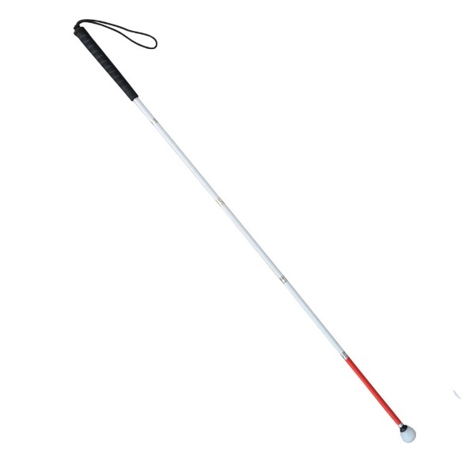

Figure 3.1.4 Cane for visually impaired

1. Zigbee transceiver module

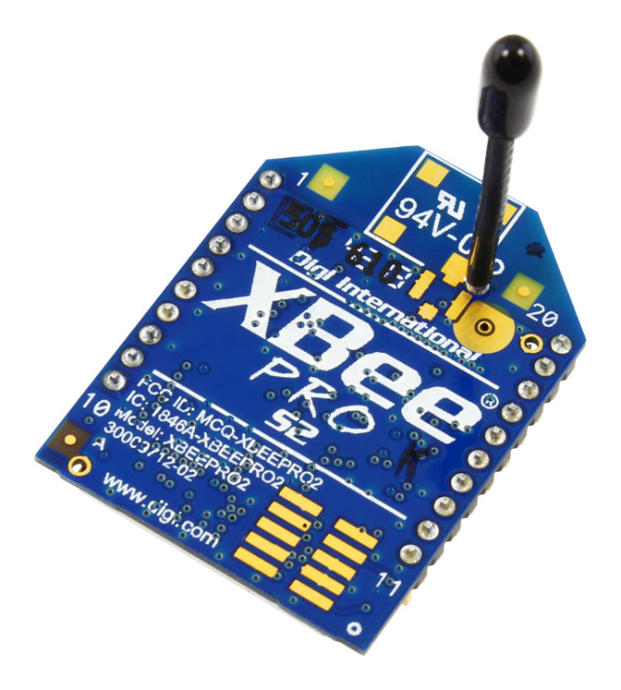The wireless transmission will be required to establish communication between the FPGA board and the sensors. XBee and XBee-PRO ZigBee RF modules provide cost effective wireless connectivity to electronic devices. XBee and XBee-PRO ZigBee modules are ideal for applications in the energy and controls markets where manufacturing efficiencies are critical. The Serial Peripheral Interface (SPI) provides a high-speed interface and optimizes integration with embedded microcontrollers, lowering development costs and reducing time to market. Products in the XBee family require little to no configuration or additional development.

Figure 3.1.5 Zigbee Wireless Module

The software comprises of the following:

1. 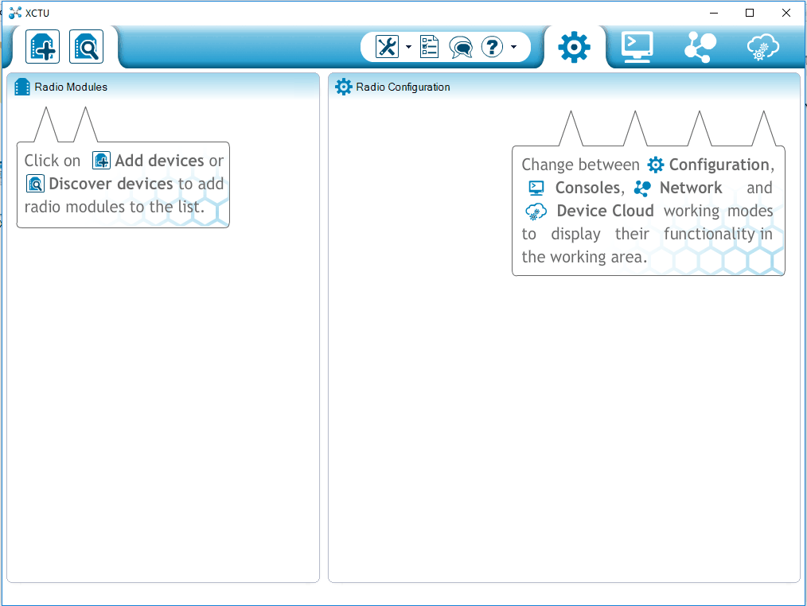XCTU is a free multi-platform application designed to enable developers to interact with Digi RF modules through a simple-to-use graphical interface. It includes new tools that make it easy to set-up, configure and test XBEE RF modules. XCTU includes all of the tools a developer needs to quickly get up and running with XBee. Unique features like graphical network view, which graphically represents the XBee network along with the signal

Figure 3.1.6 X-CTU Dashboard

strength of each connection, and the XBee API frame builder, which intuitively helps to build and interpret API frames for XBees being used in API mode, combine to make development on the XBee platform easier than ever. This application will be used to communicate with Zigbee RF modues.

1. 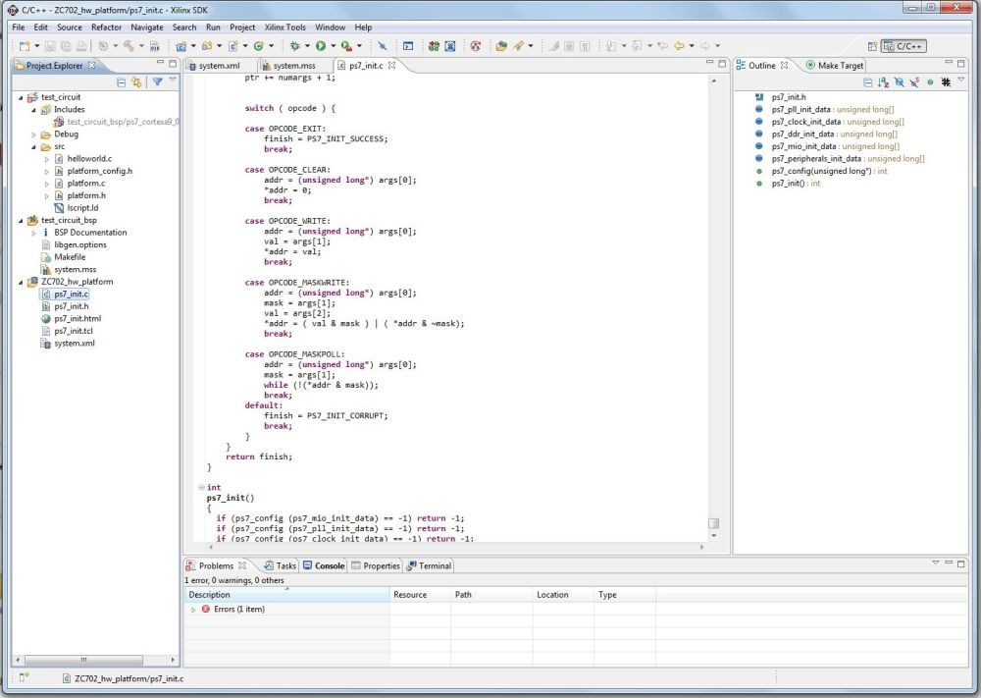The Xilinx Software Development Kit (XSDK) is the Integrated Design Environment for creating embedded applications on any of Xilinx's microprocessors. The SDK is the first application IDE to deliver true homogenous and heterogeneous multi-processor design, debug, and performance analysis. This application will be used for interacting and programming the FPGA.

Figure 3.1.7 Xilinx Software Development Kit

Table 3.1 (a) Hardware Component List

|  |  |  |  |
| --- | --- | --- | --- |
| **Sr. No** | **Name of Component** | **Specification** | **Quantity** |
| 1 | FPGA Artix-7 | Up to 16x16.6G GTs, 930 GMAC/s, 13Mb BRAM, 1.2Gb/s LVDS, DDR3-1066 | 1 |
| 2 | Microsoft Kinect | Data streaming: 320×240 16-bit depth @ 30 frames/sec 640×480 32-bit colour@ 30 frames/sec 16-bit audio @ 16 kHz | 1 |
| 3 | Mini Vibration Motor | Operating Voltage: +5V  Signal output indication  Size: 32mm X22mm X30mm Working Voltage: DC 6V | 1 |
| 4 | Regular Walking cane | General Cane length of 48.82 inch and weight of 0.53 lb | 1 |
| 5 | Zigbee Module | 2.4 GHz for worldwide deployment.  Common XBee footprint for a variety of RF modules.  Industry leading sleep current of sub 1uA.  Firmware upgrades via UART, SPI or over the air  Migratable to DigiMesh and ZigBee PRO protocols. | 2 |
| 6 | Jumper Wires M-M, M-F, F-F | It is used for connecting purposes. | 1 |

Table 3.1 (b) Software List

|  |  |  |
| --- | --- | --- |
| **Sr. No.** | **Name of Program** | **Software Version** |
| 1 | X-CTU | 6.3 |
| 2 | Xilinx Software Development Kit (XSDK) | 2019.2 |

**3.2** **Project Planning**

Table 3.2 (a) Project Planning

|  |  |  |  |
| --- | --- | --- | --- |
| **Sr. No.** | **Date** | **Work Plan** | **Work Progress** |
| 1. | 14th July 2021 | BE Project Title  Finalization w.r.to  Domain & category | Finalization of topic and domain. |
| 2. | 15th July 2021 | Problem Definition & Problem Statement | First draft of both problem statement and definition was prepared |
| 3. | 16th July 2021 | Literature Survey -1 | Research papers related to sensors, fpga and design were collected and read. |
| 4. | 17th July 2021 | Block Diagram of project. | First draft of the Block diagram was prepared. Hardware and software applications were shortlisted. |
| 5. | 18th August 2021 | Literature Survey -2 | More research papers related to FPGA and Blind assistance systems were collected and read. |
| 6. | 18th August 2021 | Final Block Diagram | Block diagram was finalised along with hardware and software applications needed. |
| 7. | 18th August 2021 | Preparation of PPTS of Presentation –I | PPT presentation - I |
| 8. | 1st September 2021 | Evaluation-I | Project presentation evaluation by guide |
| 9. | 6th October 2021 | Evaluation-II | Project presentation evaluation by guide |

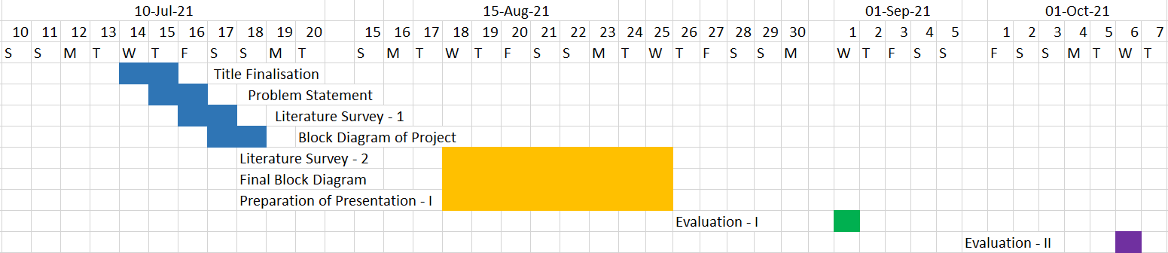

Figure 3.2 Gantt Chart

**Chapter 4**

**Design Phase**

**4.1 Designing of Block Diagram**

The planning of the diagram plays a really vital role because it visually describes the system as a whole displaying the significant elements of the system. The diagram below is the block diagram of the project.

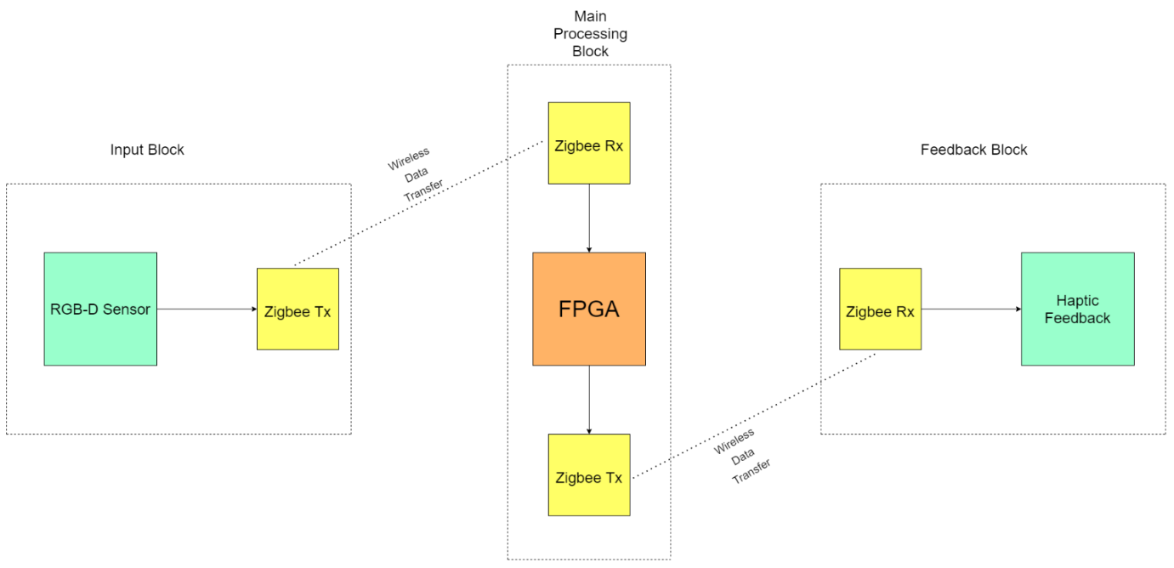

Figure 4.1 Block Diagram

1. The input side comprises an RGB-D sensors and a Zigbee transmitter, i.e., which senses the depth and RGB image of surrounding around the user and gives readings to the FPGA Board using Zigbee Transmitter.
2. Two Zigbee transmitter and two Zigbee receiver are used for wireless transmission of data.
3. FPGA Board is used for processing of data received from sensor.
4. After the processing of received data by FPGA, it sends signal to vibration motor using Zigbee transmitter.
5. The vibration motor is used to send vibration signal to the user to aware him/her about the obstacle/objects around them.

**4.2 Designing of Model**

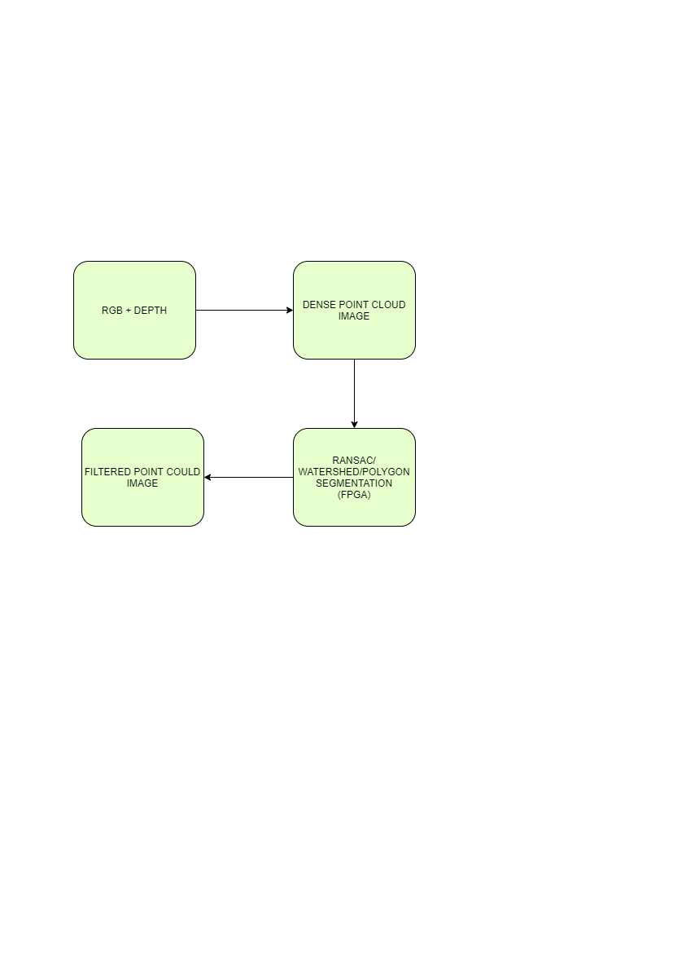

Figure 4.2 1 Block Diagram of Image Processing

The RGB-D device provides range information from active sensing by means of infrared sensor and intensity images from a passive sensor such as a standard camera. So RGB-D sensor is used as sensing element to take image of surrounding.

This is the only sensor used in this paper, which benefits from both the range and visual information to obtain a robust and efficient system.

The camera takes grey scale picture of scenery and creates point clouds in image along with skeleton structure for better classification of object.

The information is transferred to FPGA board with the help of zigbee transmitter.

Algorithm such as RANSAC, Watershed Segmentation, Polygon Segmentation is used to sample down the densely populated point could in image.

By sampling down the image, we eliminate unnecessary information in an image.

The sampled down image has a smaller number of point clouds which has only essential information about the surrounding.

After analysing the image, the feedback is given accordingly using a haptic feedback.

Vibration motor is used for feedback. Signal is sent to vibration motor using Zigbee transmitter.

The vibration frequency of motor changes according to distance between user and object. The shorter the distance the higher frequency of motor increases.

**Chapter 5**

**Applications**

**5.1 Possible Application of the Project**

This project is focused on assisting a Visually Impaired individual in navigating their immediate surrounding. It will be able to detect stationary and moving objects and inform about these to the user using haptic feedback. This system will be embedded in cane. The handle of the cane will act as the user interface. The design of the cane will be such that it feels familiar to the cane the user is already used to.

**Chapter 6**

**References**

**6.1 References**

1. Franjo Cecelja, Wamadeva Balachandran, Rommanee Jirawimut, “A Stereo Vision System for Pedestrian Navigation,” 17 International Conference on Applied Electromagnetics and Communications, 1 - 3 October 2003. Dubrovnik. Croatia
2. V.Dhilip Kanna, P.V.Deepak Govind Prasad, S. Aswin Amirtharaj, “Design of a FPGA based Virtual Eye for the Blind, “2011 2nd International Conference on Environmental Science and Technology
3. Jeffrey T. Johnson, Benjamin F. Johnson, Bruce B. Blasch, “Gait and Long Cane Kinematics: A Comparison of Sighted and Visually Impaired Subjects” ournal of Orthopaedic & Sports Physical Therapy®
4. Nam, J., Yeon, T. & Jang, G., “Development of a linear vibration motor with fast response time for mobile phones.”, Microsyst Technol 20, 1505–1510 (2014).
5. Alex Y, Shilpa Shyam, “Smart Cane for Blind and Visually Impaired Persons”, International Journal for Creative Journal Thoughts (IJCRT) (2020)
6. B.S. Sourab, Ranganatha Chakravarthy H.S, Sachith D’souza, “Design and Implementation of Mobility Aid for Blind People”, 2015 International Conference on Power and Advanced Control Engineering (ICPACE), (2015)
7. A. Aladren, G. Lopez-Nicolas, Luis Puig, Josechu J. Guerrero, “Navigation Assistance for the Visually Impaired Using RGB-D Sensor with Range Expansion”, IEEE 2014
8. Cheng Chen, James M. Ricles, “A General Approach for Analysis of Actuator Delay Compensation Methods for Real-Time Testing”, The 14th World Conference on Earthquake Engineering October 2008
9. Rehsma Vijay Jawale, Ravina Shantaram Gaikawad, Madhavi Vijay Kadam, Lakshmi Sudha Kondaka, “Ultrasonic Navigation based Blind Aid for the Visually Imapired”, 2017 IEEE International Conference on Power, Control, Signal and Instrumentation Engineering (ICPCSI)
10. Pakale P.B, Nikam R.G, Pawar A.M, “Survey on Assistance Systems and Navigation for Blind People Using Sensors”, IAETSD Journal for Advanced Research in Applied Sciences
11. Haichao Liang, Takashi Morie, Youhei Suzuki, Kazuki Nakada, Tsutomu Miki, Hatsuo Hayashi, “An FPGA based Collision Warning System Usign Hybrid Approach”, Seventh International Conference on Hybrid Intelligent Systems (2007)
12. Mike Trent, Kevin Laubhan, Ahmed, “FPGA based Real Time Obstacle Detection and Notification System”, ICEEOT 2016
13. Rumin Zhang, Wenyi Wang, Jianwen Chen, Yijeng Yang, Lioayuan Zeng, Sean McGarth, “An Algorithm for Obstacle Detection based on YOLO and Light Filed Camera”, 2018 Twelfth International Conference on Sensing Technology (ICST)